# Assignment 5D – Song object references

1. Import <Song.java> and <SongClient.java>. Briefly examine them to see what they do. Run SongClient.java
2. Look at this trace I prepared and make sure you understand the six variables in the trace.

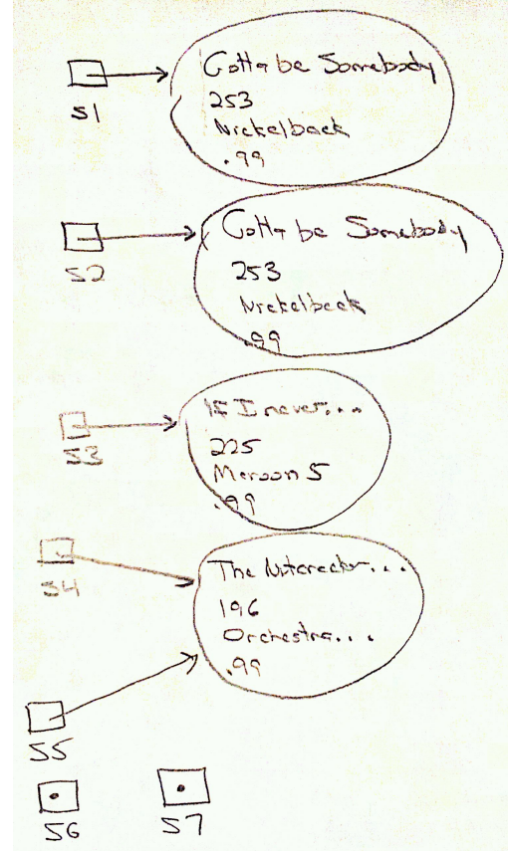

1. Test s1 to see if it is a null object reference. If it is print “s1 is null” else print “s1 is not null”
2. Test s6 to see if it is a null object reference. If it is print “s6 is null” else print “s6 is not null”
3. Test s1 and s2 to see if they reference the same object (are they the same object reference). If they do, print “s1 and s2 reference the same object” else print “s1 and s2 reference different objects”
4. Test s4 and s5 to see if they are the same object reference. If they are print “s4 and s5 reference the same object” else print “s4 and s5 reference different objects”
5. Test s1 and s2 to see if the *contents* of the objects they reference are the same. If they are print “s1 and s2 reference objects that have the same contents” else print “s1 and s2 reference objects that have different contents”
6. Test s1 and s3 to see if the contents of the objects they reference are the same. If they are print “s1 and s3 reference objects that have the same contents” else print “s1 and s3 reference objects that have different contents”
7. See what happens when you try to call a method on an object reference that is null. First call getArtist() on s1 and print the results. Next try to call getArtist() on s6. This should cause an error when you run the program. Make sure you understand why. Leave the error in the program.
8. Make sure that the output from the program matches what you would expect to happen.